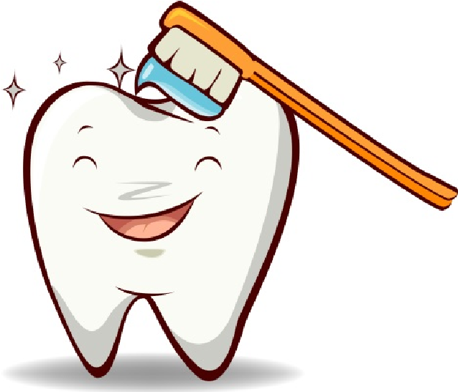
ORAL HEALTH CARE PLAN
Even before teeth appear it’s important to take care of your gums. CKLC provides Oral Health Care to help prevent early childhood tooth decay.
  - Children 6 weeks to 1 year we gently swab the gums once a day using soft gauze following a feeding. The gauze is discarded after each use.
  - Children 1 to 6 years of age use a small child size toothbrush with a small cup of water once a day.
________ ________ _________ _________ _________ ________ ________ ________ ________

Teaching children to brush using small circles where teeth and gums meet is a proper technique. Children need to brush both the cheek and tongue, and the sides of the teeth, and the flat chewing surfaces.
Using the correct amount of mouth rinse a child can brush without having to swallow or rinse. Once the brushing is complete a teacher rinses the toothbrush, stores it in its proper designated place to air dry.
CKLC will provide each child with a toothbrush and mouth rinse. By signing below you agree to the Oral Health Care Plan and would like your child to Participate.

CHILD’S NAME:______________________________________ Date: _____________________________
PARENT SIGNATURE:___________________________________________________________________

